Git is the open-source software that actually manages the git commands as a VCS.
GitHub is the online hosting provider that can act as a machine connected to our local machine via the internet and host code in a repository for us.
git init:
  - This command initializes a Git Repository on your local machine.
  - You only need to run this command once per project.
git status:
  - This command will report back the status of your Git repository.
- Upon creating a repository with git init you will create a hidden .git file.
- The .git file is a hidden file that manages the versioning of the files inside the Git repository.
- Git inside a Folder/Directory:
  - Upon creating a Git Repository, all the folders/directories inside the top level Git Repository will also be part of that Repository, meaning all the changes are tracked.
- Create Personal Access Tokens (PAT) on Github.com
When using the git clone command, reference the PAT.
- Clone Syntax with Personal Access Tokens (PAT):
git clone https://token@github.com/account/repo.git
- Clone without Personal Access Tokens (PAT):
git clone https://github.com/account/repo.git
- Changing code in a Repository to staging area
git add .
- Committing these changes
  - git commit
- Pushing or Pulling Changes
  - git push and git pull
- Checking Status, Logs, and Changes
  - git status, git log, git diff
- Changing code in a Repository & adding it to staging area
  - git add
- Committing these changes
  - git commit
- Pushing or Pulling Changes
  - git push and git pull
- Checking Status, Logs, and Changes
  - git status, git log, git diff
- to add a remote branch using the git remote command syntax:
  - git remote add name https://url.git
- By convention, we call this remote branch the origin branch.
  - git remote add origin https://url.git
- git remote rename <old> <new>
- git remote remove <name>
- Once we’ve connected to our remote branch on GitHub, we can push our code to the remote branch.
- We tell git to push to the remote main/master branch called origin with the command:
  - git push -u origin main/master

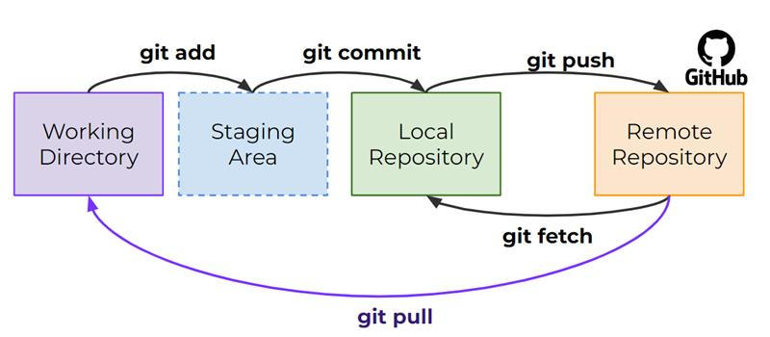

Using git fetch will download changes from the GitHub remote repository, however you will not see those changes be part of the files you have in the working directory.
- Fetch allows you to grab additional work done on the remote master branch, without needing to merge it in your working directory files.
- Using git fetch makes sense when you’re working with others and want to see what changes they’ve made but aren’t ready to overwrite your own files yet.
- Also if you are simply working by yourself, you may want to just fetch remote changes without overwriting your latest work (later we’ll discover branches are a better way of doing this).
- Using git pull makes sense when you want to directly grab changes from the remote branch and directly merge them into your current branch.
- This means you will literally update the files in your working directory to match up and merge with the remote branch.
- If you’re a solo developer working on a single master branch, you often skip using a combination of git fetch and git merge and go straight for a git pull.

- Branches allow us to organize a repository and split it apart so multiple people can work on it or so a solo developer can work on different aspects of a project on a separate work.
- Git Branch Commands:
git branch, git switch, git checkout
- Branches
  - A branch represents an independent line of development.
  - Branches serve as an abstraction for the edit/stage/commit process.
  - They are a way to request a brand new working directory, staging area, and project history.
- Branches are just pointers to commits.
- When you create a branch, all Git needs to do is create a new pointer, it doesn’t change the repository in any other way.
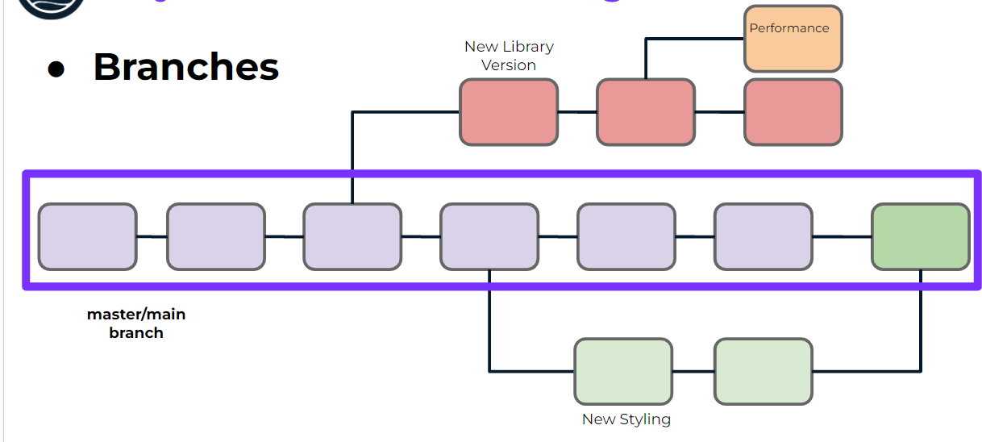

o Upon creating a new repo with git init you create a new branch called the master branch (or main branch).
o This is a branch just like any other, but it’s simply the first one created.
§ Should the code pushed to the master branch always be in working condition?

Master:
o While organizations and developers often treat this master branch as the official branch for things like deployment, this is not a requirement.
o You can use any branch for code deployment or code that’s actually “in-use”.
- Master vs. Main
- GitHub has changed the nomenclature for this initial branch to be main branch while Git is still using master branch
- Branches are just pointers to commits.
- When you create a branch, all Git needs to do is create a new pointer, it doesn’t change the repository in any other way.

- HEAD will help us understand what we are currently “viewing” or where we are “located” in regard to branches and commits.
- A HEAD is simply a reference to a commit object.
- We can think of HEAD as pointing to a specific commit in a branch that we are currently viewing.
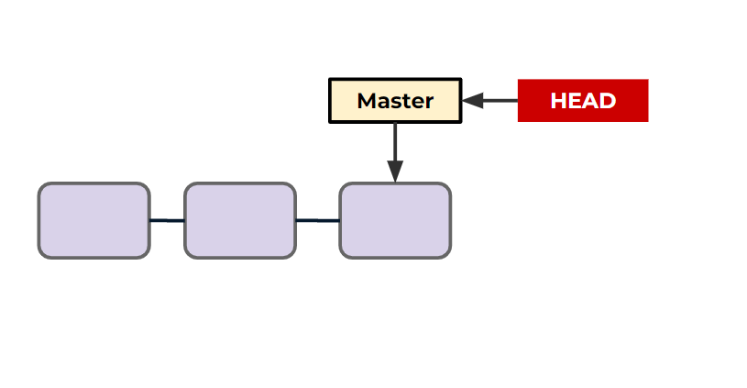

o Create a New Branch
§ git branch <branch_name>
o Report Branches
§ git branch
o Switch Branches
§ git switch

- Deleting a Branch
  - git branch -d branch_to_delete_name
    - You can not delete a branch you are checked out at.
    - You also will get a warning if the branch is not merged.
      - You can confirm you want to do this anyways with -D

Merges:
When a new branch is created, but the original branch it stemmed(created) from has no additional commits. This is known as a “fast-forward” merge

- Merge in Practice
  - Fast Forward Merge
  - Multiple Branch Commit Merge with No Conflict
  - Multiple Branch Commit Merge with a Conflict

git checkout: git checkout -b <branch-name>
  - This is actually a very versatile command, so versatile in fact, that developers complained it was used for too many different actions, thus new git commands were created, such as git switch.
  - A "checkout" is the act of switching between different versions of a target entity.
The git checkout command can operate on three distinct entities: files, commits, and branches.
  - We can check out a particular commit by specifying its hash, we can get hashes from the git log command and we can also see the abbreviated hash using:
    - git log --oneline
  - Then we can provide the hash as:
    - git checkout #######
- Typically, our HEAD points to the branch which points to the latest commit.

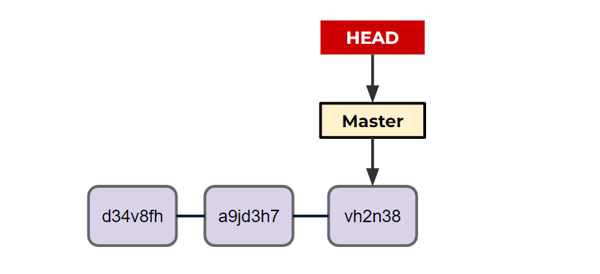

Upon calling git checkout a9jd3h7 we detach the HEAD to a previous commit
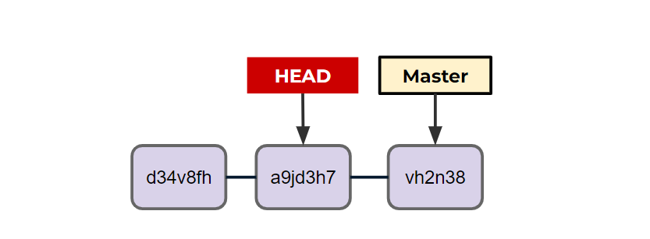

- You can think of this as traveling back in history to what your code looked like when you ran this commit.

git reset:
Allows us to remove commits and “reset” the branch.
- There are two main types of git reset calls:
  - git reset #######
    - Removes commits in front of the specific hash called, files unchanged.
  - git reset ####### --hard
Removes commits and the changes in the files.

- We can visualize a git reset moving back to a previous commit, but not undoing file changes (unless it is --hard)
git reset without hard
git reset with hard
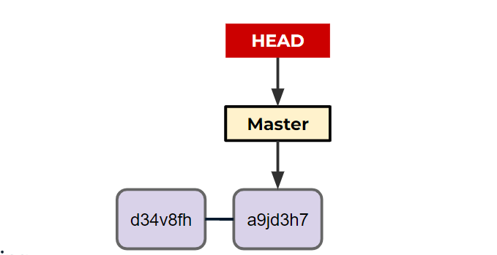

- A git revert creates a new commit that matches the historical state of a previous commit.

- The git revert command is a forward-moving undo operation that offers a safe method of undoing changes. Instead of deleting or orphaning commits in the commit history, a revert will create a new commit that inverses the changes specified.
- Git revert is a safer alternative to git reset in regards to losing work.
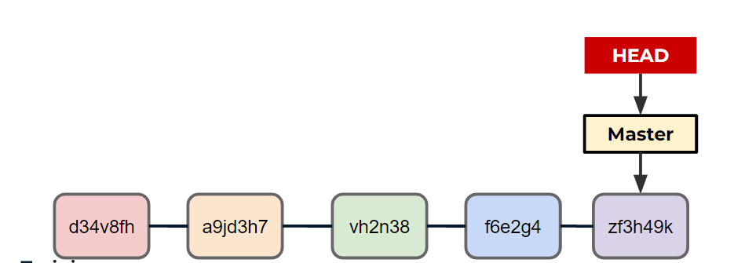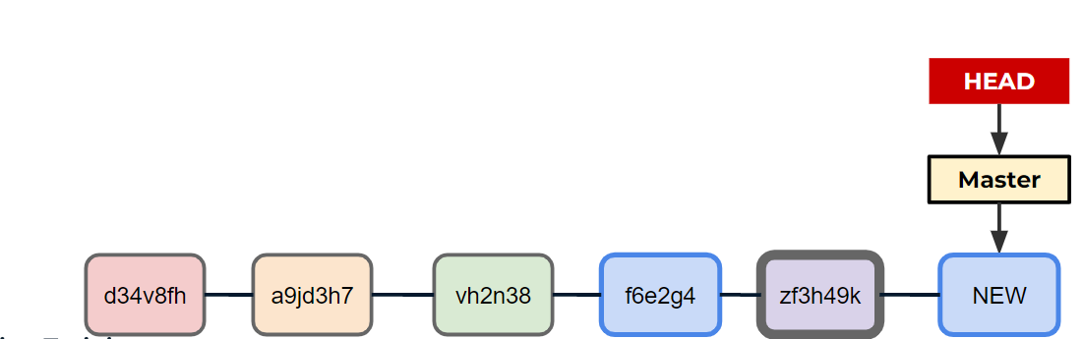

git stash:
  - Temporarily shelves (or stashes) changes you've made to your working copy so you can work on something else, and then come back and re-apply them later on.
  - Stashing is useful when you find yourself needing to quickly switch branches to work on something else, but are in the middle of changing a file.
GitHub Actions:
Is a continuous integration and continuous delivery (CI/CD) platform that allows you to automate your build, test, and deployment pipeline.
- You can create workflows that build and test every pull request to your repository, or deploy merged pull requests to production.
- GitHub Actions are executed upon an event, and the “runners” of jobs can be stacked on top of each other:
- If you work on large projects with many users on GitHub, you’ll often see GitHub actions in use to help maintain the codebase.
- The actions themselves are YAML files with instructions for what GitHub should do upon an event.

Ways to view your remote URL:
- Use the git remote -v command. This will list all of your remotes, along with their URLs.
- Use the git config --get remote.origin.url command. This will print the URL of the remote named origin.
- Use the git ls-remote --get-url origin command. This will print the URL of the remote named origin, even if it is not the default remote.
The -M option in git is used to move a branch to a new location. For example, if you have a branch named master and you want to move it to a new location called main, you would use the following command:
git branch -M main
This will move the master branch to the main branch.

